PAINT-A-HYDRANT Application  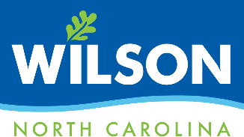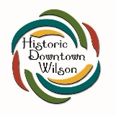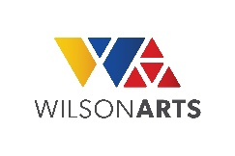  To sponsor, design and paint a hydrant in the Historic Downtown Wilson Municipal Service District (MSD), submit the completed application with payment and a color sketch on the provided template. | 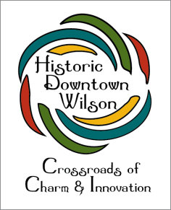

APPLICATION DUE BY: 5 pm, Tuesday, May 3, 2024

EVENT: Saturday, June 1, 2024 at 10 am.

Contact Information
Business or Group
Contact Name
Street Address
City, State, Zip
Phone
Email Address

Preferred Hydrant Location - Identify by hydrant number on map
1st _______________ 2nd ________________ 3rd _________________

Attach sketch (in color) on provided template. If you would like to sponsor a hydrant, but need assistance in designing or painting your hydrant, you may partner with an artist, school or group to develop and execute the design. You are responsible for contacting and selecting your art partner; however, we can assist with suggesting possible art partners. If your submitted design is not initially approved, changes may be made to meet the guidelines or you may receive a refund.

COMPLETED application, sketch & payment due to Wilson Arts by
5 p.m. on Tuesday, May 3, 2024.

Please make checks payable to Wilson Arts.
Reference business/group name on checks to ensure payment is credited correctly.

Mail or hand-deliver to: Wilson Arts
ATTN: Cathy Hardison
204 Nash Street S
Wilson, NC 27893
Open Tuesday-Saturday 10:00 a.m. – 5:00 p.m.

